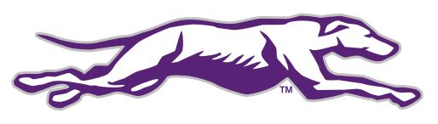
STATE CHAMPIONSHIPS

1958 Boys Track 120 Yard Hurdles (Richard Herms)
1984 Girls Golf Medalist (Patsy Baxter)
1985 Girls Golf Medalist (Patsy Baxter)
1998 Girls Track 800 Meter (Courtney Darter)
1998 Boys Track 800 Meter (Adam Comer)
2003 Boys Cross Country
2004 Baseball
2004 Boys Cross Country
2006 Boys Soccer
2007 Softball
2007 Boys Track 1600 m (Lorin Wilson)
2008 Boys Tennis Doubles (Cameron Davis and Grant Gandy)
2017 Boys Tennis (Ryan Koth)
2017 Girls Tennis (Alexa Rice)
2017 Spring Tennis
2018 Boys Tennis (Ryan Koth)
2018 Girls Tennis Doubles (Catherine Coe and Georgia Rice)
2018 Girls Tennis (Alexa Rice)
2018 Spring Tennis
2019 Tennis Doubles (Catherine Coe and Georgia Rice)
2019 Spring Tennis
2021 Boys Soccer
2022 Boys Soccer
2022 Boys Tennis Singles (Justin Koth)
2023 Boys Tennis Doubles (Sam & Jess Gonzales)

